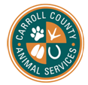
WELCOME!
First and foremost, THANK YOU for gifting your time to our shelter dogs! By taking them out for just a few hours a day, our temporary residents can exert pent up energy as well as be mentally stimulated to new experiences and people! As a result of a Come Over Rover, our dogs are less anxious or exuberant when they meet potential adopters and they gain useful life skills that they wouldn’t get from just sitting and waiting in the shelter. Another added bonus is that people who are not likely to come into shelters are still able to see our available animals and we gain important information about their personalities outside of the shelter setting!

Important Phone Numbers and Contacts
Carroll County Animal Shelter: 770-214-3590/ Fax number: 770-834-6886
For general question/ info /non-emergencies:
Sellis@carrollcountyga.com
470-222-0210 (after hours emergencies)

Contact Name: Shelby Duren
Email: SDuren@carrollcountyga.com
770-214-3590

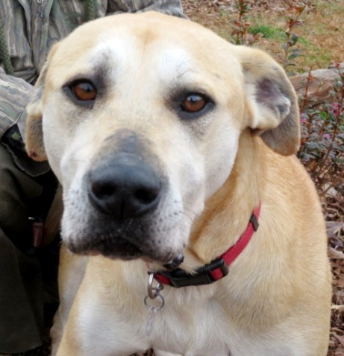
In case of an emergency
Please call 770-214-3590 and return dog immediately
***All visits to the emergency clinic must be approved in advance***
Bowdon Animal Hospital, 145 City Hall Ave, Bowdon, GA 30108 770-258-3256.
Susan Ellis-Director-470-222-0210 (after hours)

Emergencies that require immediate attention:

- Sudden or blowout diarrhea where dog has no control at all
- Temperatures over 104 degrees
- Extreme dehydration – If you pinch the skin and the skin remains tented for 5 seconds. (The eyes may appear to be sunken in. The gums will feel dry or tacky.)
- Excessive vomiting or vomiting blood or green or yellow bile
- Vomiting combined with diarrhea and lethargy
- Difficulty breathing or very shallow or labored breathing
- Extreme lethargy - dog is barely moving or not moving at all
- Swelling of the face or eyes
- Prolapsed rectum
- Ingestion of something toxic
- Swollen or broken limbs
- Seizures
- Uncontrolled bleeding
- Sudden disorientation or lack of coordination
- Anything else that makes you think that your dog is in pain or in danger of passing away

Non-emergency concerns can be noted at the time of drop off
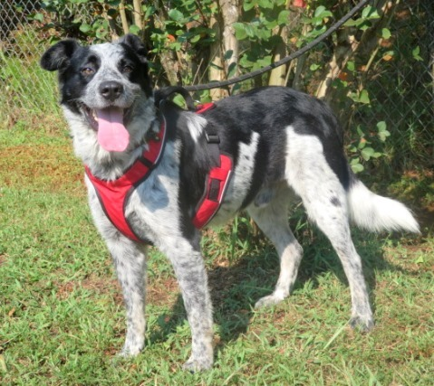

Before You Pick Up Your Dog

- Be prepared for anything. Remember, we don’t know what many of these dogs have been through. We don’t know their past, we don’t know how they have been treated, we don’t know how their living situation once was, and most importantly, we don’t know their true personality. All we do know is what we see here at our facility and what little (if any) information her previous caretaker provided. We try our very best to match you with a dog that we think will do well with you, but your dog may have a very different personality once they are comfortable.
- Ready your car with the appropriate amount of space for the dog. Depending on the dog, you may need enough space for a size appropriate crate, a friend to help contain the dog to the back seat, or a barrier to avoid the dog from getting to the driver and passengers seat.
- Please plan to leave your own dog at home! The goal of our day trips is to give the dog a break from the shelter and some one on one time with humans. Although most of our shelter dogs do well with other dogs and enjoy doggie playtime, we prefer these field trips be geared towards interacting with humans and not with other dogs. Carroll County Animal Shelter is not liable for the treatment or cost of vet bills incurred for your own pets at your private veterinarian.
- If you plan to take your dog home, please check your fence line and property for holes, loose planks, poisonous plants, foxtails, and dangerous household items. Even if you have/had a dog that has never gotten loose, please don't assume that your property is secure. We don't know the history of most of the dogs we place and the majority of them were strays.
Carroll County Animal Shelter will provide you with a leash, collar, ID tag, doggy seat belt, poop bags, water bottle, water bowl, crate if needed, and some doggy business cards!

IF YOUR DOG GETS LOOSE:

Sometimes despite our best intentions, a dog will get loose. Please try not to panic. If you can see the dog, try calling them. Some of our more social guests may come right to you, but very often even social dogs get frightened once they get loose. You may be more successful calling them to get their attention and then walking the opposite direction, kneeling down and digging in the dirt like you've just found something extremely interesting. Reaching for a scared dog will often cause them to bolt and can also result in a bite, so please use caution and only reach for the dog if you feel you can safely do so. If the dog is in an area that is secured but is so scared that they are growling at you, please call us so that we can help! If the dog is already in a flat out run and is panicked, they may not respond to you at all. Please try following them from a distance so that you can see the direction they are going and hopefully catch up to them once they have slowed down. If they enter a yard, garage, etc., please secure the area to make sure they can't bolt again before attempting to lure them to you. We understand that every circumstance is different and that luring your dog to you may not be possible, please call us if this is the case!

IF A BITE OCCURS:
If the dog bites anyone (you included) we need to know right away. If the dog bites a stranger, please take all of their information so that we can contact them to fill out the appropriate paperwork. We will need you to document what happened and the location and severity of the wound. We are required by law to report any bites that break skin to the appropriate animal control agency. We will also need to follow state laws for quarantine. A bite is not an automatic reason for euthanasia, so please do not hesitate reporting it. If you are seeing any signs of aggression, even if it is very minor, please contact your coordinator immediately.



IF SOMEONE IS INTERESTED IN ADOPTING
If you encounter someone who is interested in adopting your dog, please give them the dog’s business card so that they may follow up with them. You can also direct them to your coordinator. In general, the adoption fee for adult dogs is $50 and includes spay/neuter, rabies vaccine, distemper/parvo vaccine, heartworm test, heartworm prevention and microchip. The majority of our adoptions occur as a result of the dogs being seen on our website. It is very important that we have adorable photos, and if possible a great video of your dog. Please share these at sellis@carrollcountyga.com. We need your help to make sure your dog is seen as much as possible!

AS A PARTICIPANT, YOU MUST AGREE TO
- Have the dog under YOUR supervisor at all times
- Never leave children unattended with any dog
- Inform us if the dog bites anyone (you included) right away
- Keep the dog on leash unless confined in your home/back yard.
- Do not take the dog to off-leash dog areas, dog parks, or do dog introductions while on your trip
- Pick up and return the dog at the agreed upon times
- Transport the dog in a safe manner by either being in a crate or safely restrained in a back seat
- Keep the dog offsite (do not walk it around Carroll County Animal Shelter's property)
- Report any behavior or medical concerns to your coordinator
- Keep the dog safe by providing adequate rest, shade, shelter and water
- Utilize only positive reinforcement training (do not verbally or physically punish the dog)
- Have a cell phone with you at all times that can be used to contact you
- Present the dog in a positive way to potential adopters and members of the public
OH, THE PLACES YOU CAN GO!

The Greenbelt
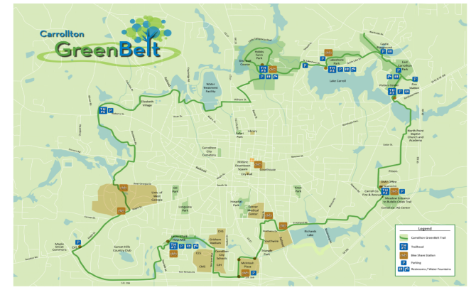
https://www.carrolltongreenbelt.com/

Carroll County Parks
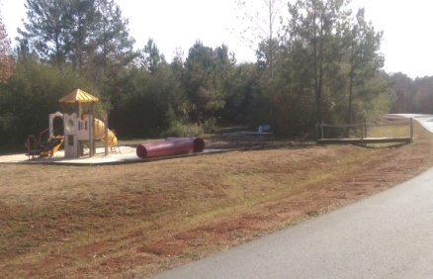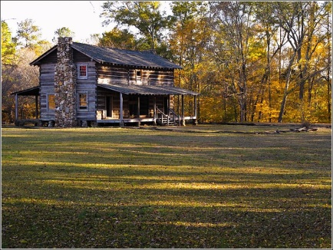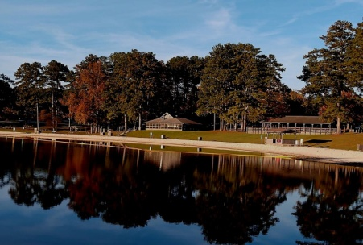
Little Tallapoosa Park McIntosh Reserve Park John Tanner Park

https://carrollcountyga.com/289/Parks-Facilities

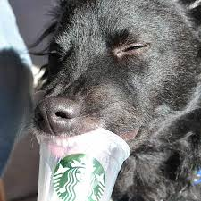
Or go by Starbucks for a Puppuccino!

Woo-Hoo! Come Over Rover!

We love to see and hear about your adventures today and pictures of your day can help them find an awesome forever home.

If you post pics on social, please tag us:
Facebook: @ccasgarescue
Instagram: @CCASGeorgia
Use the hashtag #comeoverrover

We re-post and re-gram!
You can also send photos to sellis@carrollcountyga.com

