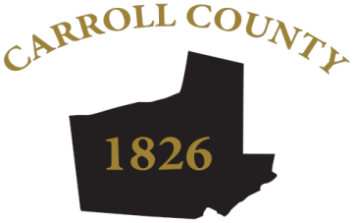

AGENDA

CARROLL COUNTY, GEORGIA
BOARD OF ELECTIONS & REGISTRATION MEETING
May 28, 2024 – 4:30 PM

- Call to Order – Chairman

- Roll Call – Chairman

- Public Comment – (Speakers limited to 3 minutes)

- Approval of April 25, 2024 BOER Minutes – Chairman & Board

- Certification of May 21, 2024 General Primary/Nonpartisan Election Results – Chairman
  - Signing of Certification Paperwork

- Election Supervisor Updates –
- Election Updates

- Approval of List Maintenance of Perfect Matches: April 25, 2024 – May 21, 2024
  - Vitals for Removal – 87
  - Felons for Removal – 57
  - Duplicates – 5
  - Total Cancelled – 149

- Board Meeting Schedule for 2024 – Chairman
June 21, 2024 – Proposed in Conjunction with Certification of June 18 Runoff
July 25, 2024 – Proposed, but Subject to Board’s Input

- Adjournment - Chairman

